**Rapid Application**

**Development**

**IS 2104**

* + - * + **W.H.M.GUNATHILAKA**
        + **2018/IS/027**
        + **18020275**

**Q1.**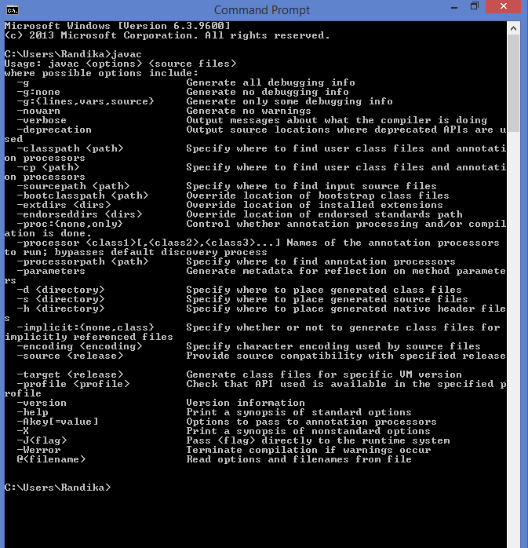

**Q2.**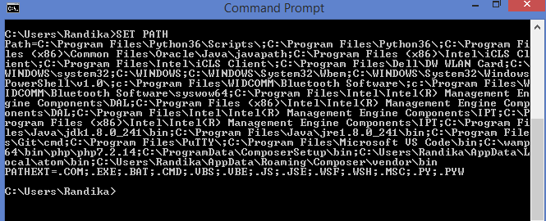

In the 11 th row,provement is there.(\Java\jdk1.8.0…..)



**Q3.**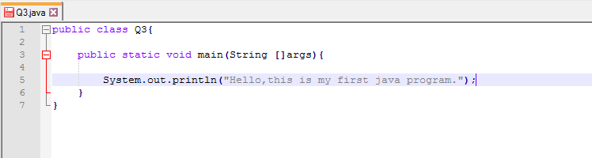

**Q4.**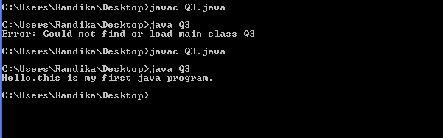

**Q5. ” Java programs are compiled and interpreted”**

In programming languages like C and C++, the human readable source code is converted directly into the machine readable binary code or machine code.

But in java,there is an intermediary code called Byte Code. In the compilation of the program,the java compiler converts the source code into Byte code.

In the interpretation process the JVM (Java Virtual Machine)converts the byte code into Binary code or Machine code.

Java is a compiled programming language, but rather than compile straight to executable machine code, it compiles to an intermediate binary form called JVM byte code. The byte code is then compiled and/or interpreted to run the program.

So the java programs are both compiled and interpreted.